# Creating Microservices for account and loan

In this hands on exercises, we will create two microservices for a bank. One microservice for handing accounts and one for handling loans.

Each microservice will be a specific independent Spring RESTful Webservice maven project having it's own pom.xml. The only difference is that, instead of having both account and loan as a single application, it is split into two different applications. These webservices will be a simple service without any backend connectivity.

Follow steps below to implement the two microservices:

## Account Microservice

* Create folder with employee id in D: drive
* Create folder named 'microservices' in the new folder created in previous step. This folder will contain all the sample projects that we will create for learning microservices.
* Open https://start.spring.io/ in browser
* Enter form field values as specified below:
  + **Group:** com.cognizant
  + **Artifact:** account
* Select the following modules
  + Developer Tools > Spring Boot DevTools
  + Web > Spring Web
* Click generate and download the zip file
* Extract 'account' folder from the zip and place this folder in the 'microservices' folder created earlier
* Open command prompt in account folder and build using mvn clean package command
* Import this project in Eclipse and implement a controller method for getting account details based on account number. Refer specification below:
  + Method: GET
  + Endpoint: /accounts/{number}
  + Sample Response. Just a dummy response without any backend connectivity.

{ number: "00987987973432", type: "savings", balance: 234343 }

* Launch by running the application class and test the service in browser

## Loan Microservice

* Follow similar steps specified for Account Microservice and implement a service API to get loan account details
  + Method: GET
  + Endpoint: /loans/{number}
  + Sample Response. Just a dummy response without any backend connectivity.

{ number: "H00987987972342", type: "car", loan: 400000, emi: 3258, tenure:

18 }

* Launching this application by having account service already running
* This launch will fail with error that the bind address is already in use
* The reason is that each one of the service is launched with default port number as 8080. Account service is already using this port and it is not available for loan service.
* Include "server.port" property with value 8081 and try launching the application
* Test the service with 8081 port

Now we have two microservices running on different ports.

**NOTE:** The console window of Eclipse will have both the service console running. To switch between different consoles use the monitor icon within the console view.

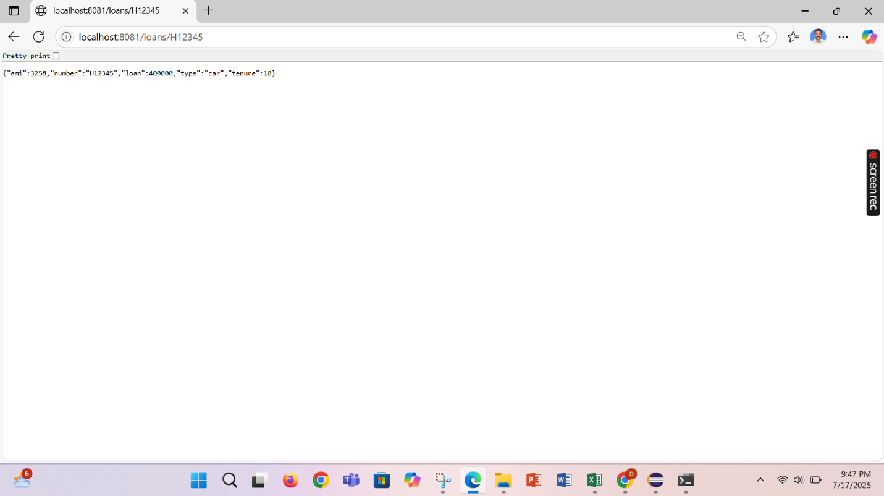

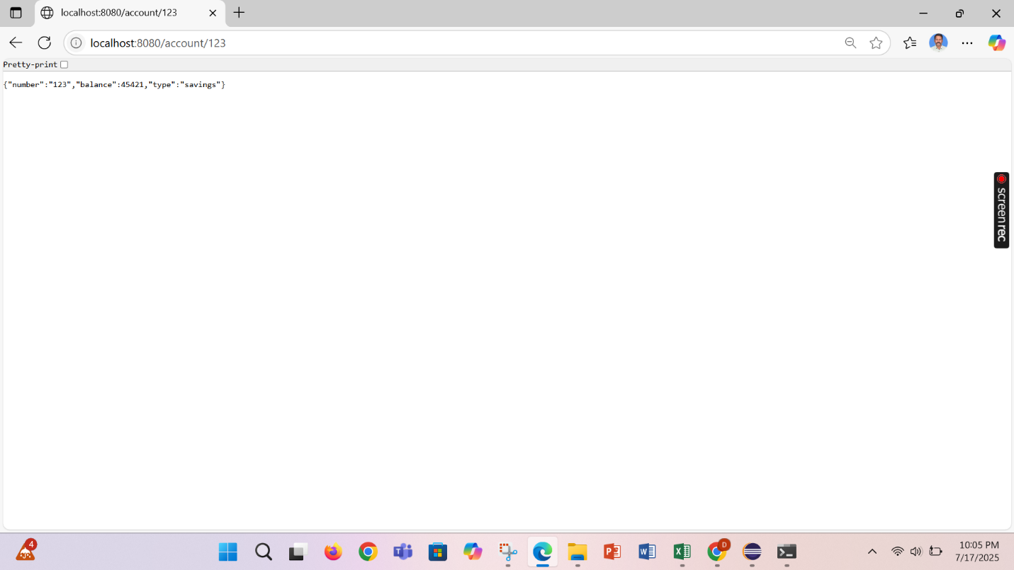

# Create Eureka Discovery Server and register microservices

Eureka Discovery Server holds a registry of all the services that are available for immediate consumption. Anybody whom wants to consume a RESTful Web Service can come to the discovery server and find out what is available and ready for consumption. Eureka Discovery Server is part of spring cloud module.

Follow steps below to implement:

## Create and Launch Eureka Discovery Server

* Using https://start.spring.io generate a project with following configuration:
  + Group: com.cognizant
  + Artifact: eureka-discovery-server
  + Module: Spring Cloud Discovery > Eureka Server
* Download the project, build it using maven in command line
* Import the project in Eclipse
* Include @EnableEurekaServer in

class EurekaDiscoveryServerApplication

* Include the following configurations in application.properties:

server.port=8761

eureka.client.register-with-eureka=false eureka.client.fetch-registry=false

logging.level.com.netflix.eureka=OFF logging.level.com.netflix.discovery=OFF

* The above configuration runs the discovery service in port 8761
* The eureka properties prohibits direct registration of services, instead discovery server will find available services and register them.
* Launch the service by running the application class
* The discovery service can be view by launching [http://locahost:8761](http://locahost:8761/) in the browser.
* This will display the discover server details
* Look into the section "Instances currently registered with Eureka", which will have an empty list
* Follow steps below to add account and loan service to this discovery server.

## Register Account REST API to eureka discovery

* Go to https://start.spring.io and provide the following configuration:
  + Group: com.cognizant
  + Artifact: account
  + Modules:
    - Spring Boot DevTools
    - Eureka Discovery Client
    - Spring Web
* Click "Explore", which will open pom.xml
* Use copy option in the opened window to copy the pom.xml and overwrite the pom.xml in account project
* Build the project using maven in console
* Include @EnableDiscoveryClient annotation to application class of account project
* Include application name for account application as specified below in application.properties. This is the name that will be displayed in the eureka discovery registry.

spring.application.name=account-service

* Stop all services (account, loan, eureka-discovery-server) using the console window of Eclipse. Use the monitor icon in console view to switch between applications and use the Terminate button to stop the server.
* First start eureka-discovery-server and wait till the application starts completely. Then open [http://locahost:8761](http://locahost:8761/) in browser. The service list should be empty.
* Then start account application and wait till the application starts.
* Refresh the eureka-discovery-server web page in browser, the account- service will be listed in the registry
* Perform similar steps for loan application and have it registered with eureka-discovery-server.

Create a Spring Cloud API Gateway and call one microservice thru the API gateway. Configure a global filter to log each request targeting the microservice using Spring Cloud API Gateway.



